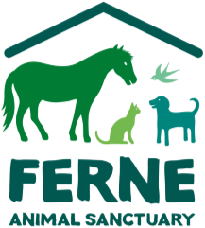

Ferne Animal Sanctuary – Design a Sign Competition
Application Form
Designer | Name:
 | Date of birth:
 | Animal Chosen:
Parent, adult or teacher submitting the application | Name:
 | Address:
 | Phone number:
 | Email address:
 | Relationship to the author | Parent Teacher Guardian
 | I confirm that I’m the parent or have parental consent to submit this application

Please post your entry with this form to;
Ferne Animal Sanctuary, Wambrook, Chard, Somerset, TA20 3DH

Please tick which any of the following methods of communication you are happy to hear from us by:
Post Email Phone Text

We are committed to only ever contacting you with news that we think you will be interested in and promise not to share your details with any other organisations.
You can opt out of these messages at any point. Thank you for completing this form.

All information that we hold concerning you as an individual will be held and used by Ferne Animal
Sanctuary in accordance with the General Data Protection Regulation and the Data Protection Act 2018. This data will be used by us to manage and administer our relationship with you, and to provide you with information about our activities and for related purposes. We will not, with-out your consent, give your name and address to any third party except where it is a necessary part of the activities that we undertake, or we are required to do so by the operation of the law.

