TRUSTEE RECRUITMENT AND INFORMATION PACK

Our Objective:
A world where people respect animals and treat them with compassion

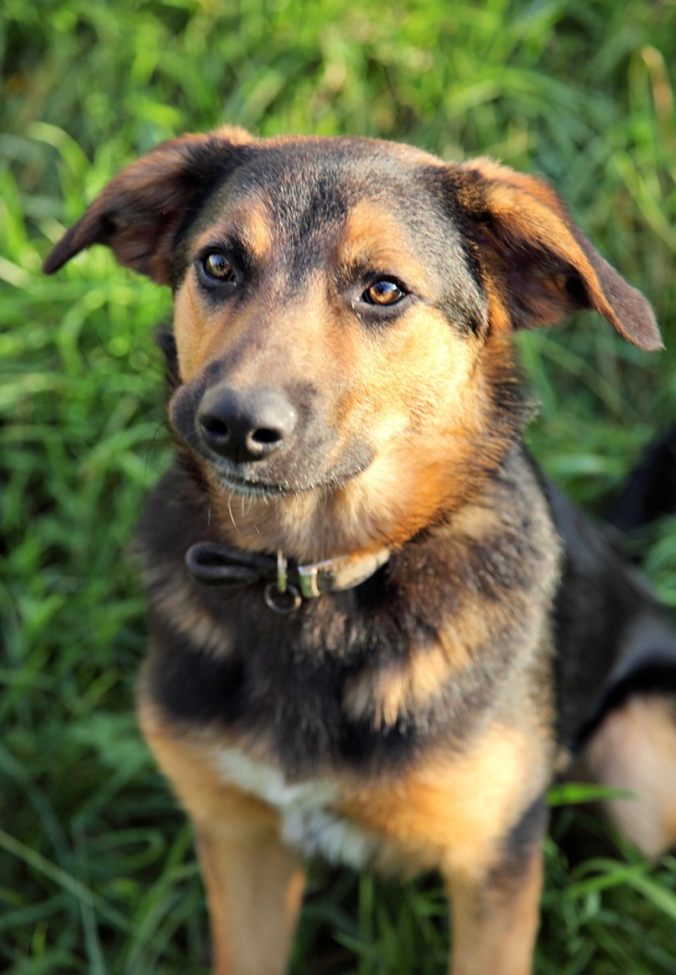

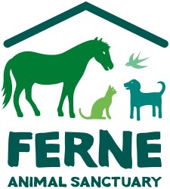

CONTENTS

Welcome Letter
Our Strategic Framework
Ferne Board of Trustees
The Role
How to Apply

WELCOME LETTER

Dear Candidate
Thank you for expressing an interest in applying to be a Trustee of Ferne Animal Sanctuary.
Ferne was set up over 80 years ago through the foresight of the late Nina, Duchess of Hamilton & Brandon – who realised that men and women going off to war had no-one to take care of their animals and so would require a temporary refuge for them.
The Duchess put a call out on the BBC and legend has it that when she returned to her London home there were a number of cats and dogs on her doorstep and also a parrot!
Ferne has invested almost £2m in the last five years in upgrading the Sanctuary provision and facilities and has a clear vision for the future. The challenges facing us as a charity are similar to those of many others: raising income, delivering our objectives and measuring impact in a world where the need for our services is growing. We are moving into an exciting phase of expansion and need committed, keen trustees to help us to achieve our vision.
We look to recruit trustees who are passionate about animal welfare, and who offer skills which complement those of our existing trustees. We need trustees with life, work and business experience and knowledge who can help us to grow the sanctuary and face future challenges with confidence.
We know through experience that different ideas, perspectives and backgrounds create a strong and creative environment which enhances our work. To that end applications are welcomed from all interested parties, regardless of age, gender, orientation or disability.
This information pack contains more information about the role and the work of Ferne. We hope you will consider joining us.
Yours faithfully,

Bob O’Connor
Chair of Trustees

STRATEGY TREE – our aims and objectives
Vision (The Long Term Goal)
A world where people respect animals and treat them with compassion

Mission (Why we exist)
To be a centre of excellence for animal care and rehabilitation through education,
support and re-homing

Strategic Aims (What we will do 2020-2024)
- To improve the welfare of animals through changing people’s behaviour
- To expand our operation to ensure we can meet the needs of the growing number of animals surrendered to us
- To maximise re-homing opportunities for all domestic and farm animals surrendered to our care
- To provide the knowledge and skills the staff and volunteers need to carry out their rolls effectively
- To maintain our policies and practices to ensure the long-term financial sustainability of the charity
- To fundraise effectively to deliver our strategy

Philosophy (How we wish to work)
We are a charity committed to serving the welfare of all domestic, farm animals and horses. We recognise that to achieve the highest standards of animal welfare, we need to equip ourselves with knowledge and skills. We will reach out to people and communities to help them better understand and take care of their animals.

FERNE BOARD OF TRUSTEES

The Trustees are appointed by the Board and meet four times a year for full Board meetings. Currently meetings are held during the working day, but we can be flexible if you are unable to attend then. Trustees are also encouraged to attend at least one sub-committee which requires another four shorter meetings, usually two weeks prior to the full meetings. We have at least one, usually two, strategy planning days during each year. Trustees stand for three years and can be re-elected for a further two, three-year terms. The Trustees also have the power to co-opt additional members onto the Board for their specific skills.

Sub-Committees:
Finance and General Purposes
Health and Safety
Fundraising and Marketing

Current Trustees:

Bob O’Connor (Chair)
Bob lives in Somerset with wife Lorraine, he returned to Somerset on retiring from his position as Managing Director of The Aspinall Foundation in April 2019. Bob spent most of his career in retail and hospitality holding senior management positions with Tesco, Rank Group and the Brighton Pier company finishing with 16 years at The Aspinall Foundation. Currently Bob runs his own leisure consultancy business Bob O’Connor Ltd. He has extensive experience as a Non-Executive Director, previous roles include Chair of BALPPA (still on management committee) Chair of Shepway Tourism Group, Member of Management Steering committee Hadlow College and Member of Natural East Kent steering Committee. Currently he is a Non-Executive director of Tourism Southeast. Bob and Lorraine enjoy far flung holidays and recently returned from an extensive tour of Southeast Asia including visits to Singapore, Malaya, Vietnam, Cambodia and Thailand. Bob follows Bristol Bears rugby and hopes to see the British Lions play in South Africa next summer.

David Cook
David spent over 50 years working in both commercial and Not For Profit organisations before retiring in 2016. His last full-time role was as Chief Executive, for 9 years, of The Donkey Sanctuary, one of the UK's largest animal welfare charities, having previously been Chief Executive of a UK publicly listed European hotel group. Since retiring, in addition to becoming a Trustee of Ferne Animal Sanctuary and Chair of the Finance and General Purposes Committee, David is also a Trustee of another animal welfare charity, a local hospice charity and a company pension scheme. Also sits on the Audit Committee of the Royal Veterinary College and is currently Chair of Sidmouth Chamber of Commerce. David has lived in Weston, Sidmouth since 2004 having spent most of his life in the Sevenoaks area in Kent.

Samantha Hannay

Samantha’s passion for wildlife began at an early age. She has kept herself involved with animals and conservation in a voluntary capacity, as well as professionally, working with RSPCA, Secret World Wildlife Rescue and British Hen Welfare Trust. Samantha has over 25 years of project management, leadership and relationship management experience within both corporate and charity sectors. She had held senior management roles throughout her career, delivering projects and managing teams and volunteers at an international level. Samantha brings a combination of marketing, communications and fundraising experience to Ferne, as well as strategy, policy and governance knowledge. Samantha’s academic qualifications include a degree in Zoology and diploma in Fundraising.

Richard Fuller

Richard has been a director and trusted advisor for over twenty years holding senior influential roles in Financial Services businesses. His most recent roles combined Human Resources Director at WH Ireland plc and Chair of the HR committee of the Financial Planning and Wealth Management trade association (PIMFA). Since leaving corporate life behind in 2019, Richard has maintained mentoring arrangements for senior HR and Finance professionals from his South Somerset base. Richard and Becky have recently expanded their family to include a kitten (Spookie) and a brood of hens! They also enjoy family time with their two adult children and granddaughter.
Samantha Wilson
Samantha has lived in Somerset for over 20 years. During her leisure time she enjoys exploring the local area and surrounding countryside and is a Governor of a local school. She is passionate about animals including Elephant and Rhino conservation and has made several trips to Kenya. Her academic skills include a degree in BSc (Hons) Strategic Systems Management. Samantha has held senior positions in Retail, Telecommunications and Finance sectors during the past 25 years and her responsibilities have included Digital and Technology transformation programmes across the UK and Europe.

Verity Stiff
Verity Stiff, is a human resources professional with experience in organisational management and development, both as head of the HR function and as a consultant. Her most recent work has involved strategic planning and the development of the human resources function and capacity. She also has extensive experience in several other human resources areas, including recruitment, performance management, job evaluation, and policy development. She is currently HR Manager with the UK office of the International Committee of the Red Cross. Verity lived and worked for many years in the U.S.A. and has a Master’s degree in Public Management (specialisation in the management of non-profit organizations) from Carnegie Mellon University. She was an active volunteer with an environmental organisation and Special Olympics. Since returning to the U.K. she has volunteered with the Devon Wildlife Trust and is a Trustee and Vice Chair of Sense International. With family in Devon and Cornwall, she has strong ties to the Southwest and is looking forward to working with the Sanctuary. In her spare time, she is a keen choral singer.

MAIN RESPONSIBILITIES OF A TRUSTEE

The Trustees’ primary role is to ensure that Ferne fulfils its charitable objectives (see page 4) and that monies received are used effectively.
In order to carry out this key role, Trustees (as a Board) must do the following:

Mandate and reputation
Ensure that the charity is properly focussed on its charitable objectives and constitution and operates within the law. The Trustees are responsible for preserving the charity’s good name and reputation.

Strategic Planning
Work with the CEO and key staff to plan strategically for the future. Meet at least once a year to review the plan, then update or replace it as circumstances and needs change. The strategic plan is a changing, active document to which all trustees contribute. It is their job to challenge, assess and review the plan before approving the final strategy for the following five years.

Objectives, work plan and budgets
Approve Ferne’s objectives and on an annual basis through the work plan and budgets that are submitted at Board meetings.

Risk Identification and Management
Ensure effective processes exist to identify, minimise where possible, monitor and manage the potential risks that the charity faces. The Risk document is reviewed and updated at each Board meeting.

Management Effectiveness and Succession
Ensure that the right management team is in place and is operating effectively and efficiently. The role of Trustees is to question, scrutinise and monitor management, for which purpose Trustees should have the opportunity to constructively question, test and challenge management views and proposals in the spirit of achieving the charity’s objectives. Although not involved in the regular appointment of new staff, trustees actively recruit and appoint the CEO, and are involved in other senior appointments.

Internal Control and Management Information Systems
Ensure that effective systems exist to protect the organisation, and the necessary management information systems exist to assess and report back the charity’s performance and progress in meeting its objectives.

Accountability
Report back yearly to members, regulatory bodies, associated charities, staff and volunteers, and other stakeholders through the Annual Report, at the Annual general meeting and from time to time through the @Ferne magazine.
The Role in practice

- The role of Trustees is to ensure that the charity is well-managed, rather than to manage it themselves (something that people often find hard). Day-to-day implementation of policy is delegated to the Chief Executive and through the Chief Executive to the rest of the staff. The Trustees’ responsibilities are to ensure that proper procedures and checking mechanisms are in place so that they can be certain that management is doing its job in a cost-efficient and effective way and that the right staff are in place to fulfil the needs of the Sanctuary.

- This in turn means that the Chief Executive is accountable to the Trustees for effective leadership and management, for implementing policies and achieving the objectives laid down by the Trustees and for appointing suitable staff.

- Trustees, advised by the Chief Executive, are responsible for setting the objectives and policies of the organisation. The Chief Executive will then develop more detailed strategies and objectives, both annual and longer term, and report on their achievement. The Trustees must consider, appraise, question and, where appropriate, challenge and improve those strategies and objectives. They must work with the Chief Executive to set yearly objectives and review outcomes at the appropriate time, working together to identify where improvement is possible. Part of their role is to support, encourage and challenge the Chief Executive and senior colleagues.

- In addition to serving the charity as Trustees, most Trustees will also contribute by making available their specialist skills and experience. It is most important that they make a clear distinction between serving as a Trustee and serving in any other voluntary capacity, for example as a member of a sub-committee, as conflicts of interest or loyalty must be recognised and managed for the good of the charity.

ROLE PROFILE

Title: Trustee

Commitment:

Four Board meetings per year, plus at least one Strategy Planning Day. Meetings take place during the working day but can be changed if the need arises. Trustees are expected, on occasion, to represent Ferne at various events and meetings. Trustees are also encouraged to be members of any sub-committee where their knowledge and skills will assist the charity. Occasionally trustees will be called on to deliver a talk for example, or to help in some other way at the Sanctuary: we are, after all, volunteers!

Trustees have the overall legal responsibility for a charity. The law describes charity trustees as ‘the persons having the general control and management of the administration of the charity.’

What matters most, however, is the role, not the title. Trustees must act together to govern the charity and take decisions. Trustees work collectively as a board and take decisions at formal board meetings. Once a decision has been collectively made all trustees are bound to support that decision. The collective approach is effective as it allows us to move forward as a Board and present a united front to staff and the public.

A successful trustee is committed to the charity, reads all the paperwork in advance, comes to meetings regularly with ideas and comments and takes a full and active part without dominating or wandering off task!

The role of Trustee is not accompanied by any financial remuneration, as we are all volunteers, although expenses may be claimed for journeys and subsistence.

PERSON SPECIFICATION

Applicants should demonstrate the following skills:

- Personal integrity
- A commitment to the objectives of Ferne Animal Sanctuary
- An understanding and acceptance of the legal duties, responsibilities and liabilities of trusteeship
- A willingness to devote the necessary time and effort to their duties as a Trustee
- Good independent judgement
- An ability to think creatively
- A willingness to contribute in meetings
- An ability to work effectively as a member of a team

Essential:

- An ability to contribute to strategic decision-making; for example, being able to ‘see the big picture’ when asked to plan strategically; being confident in putting a different viewpoint to the group and arguing for a point. Ability to abide by a collective decision even if it doesn’t go their way.

- Understanding the governance role of a Trustee; candidates will be required to show their understanding of governance as being different from executive or managerial roles and have a strong desire to gain direct experience of governance through Trusteeship of Ferne.

- Experience of representing an organisation, in informal as well as work-based settings; an understanding of the values and mission of Ferne and the ability to put this across clearly and succinctly to different audiences.

Desirable:

In addition to the essential criteria, we are particularly keen to seek applications from candidates able to meet one (or more) of the following criteria:

- Experience of another membership organisation or Charity, for example experience working for a membership organisation as a manager or in a voluntary capacity, or simply through demonstrating an in-depth knowledge of being a member of another organisation.

- Experience in the retail sector

- Experience in the law, either within the charity or commercial sector.

- Veterinary experience

How to Apply

Please write a letter in the first instance, outlining your experience and reasons for wanting to be a trustee. Include two references, and send to the following address:

Chair of Trustees
Ferne Animal Sanctuary
Wambrook
Chard
Somerset
TA20 3DH

If your application meets our criteria, you will be invited to an informal meeting with the Chair of Trustees, asked to attend two Board meetings as an observer, and finally appointed to the Board after a second meeting if all concerned are happy to go ahead. This is not a quick process, as the role of trustee is both enjoyable and challenging. We want to appoint the person who will fit our needs, work well with the team, and make a strong contribution to the future of Ferne.

Thanks for reading the application pack. I do hope you will feel able to apply. Ferne is a wonderful organisation which does such good work to give hope and new homes or sanctuary to hundreds of animals each year. Your contribution to our aims will be much appreciated, and I hope a rewarding, fulfilling experience for you.

Yours sincerely

Bob O’Connor

Enclosed:
Annual report
The Essential Trustee
@Ferne magazine

